1. 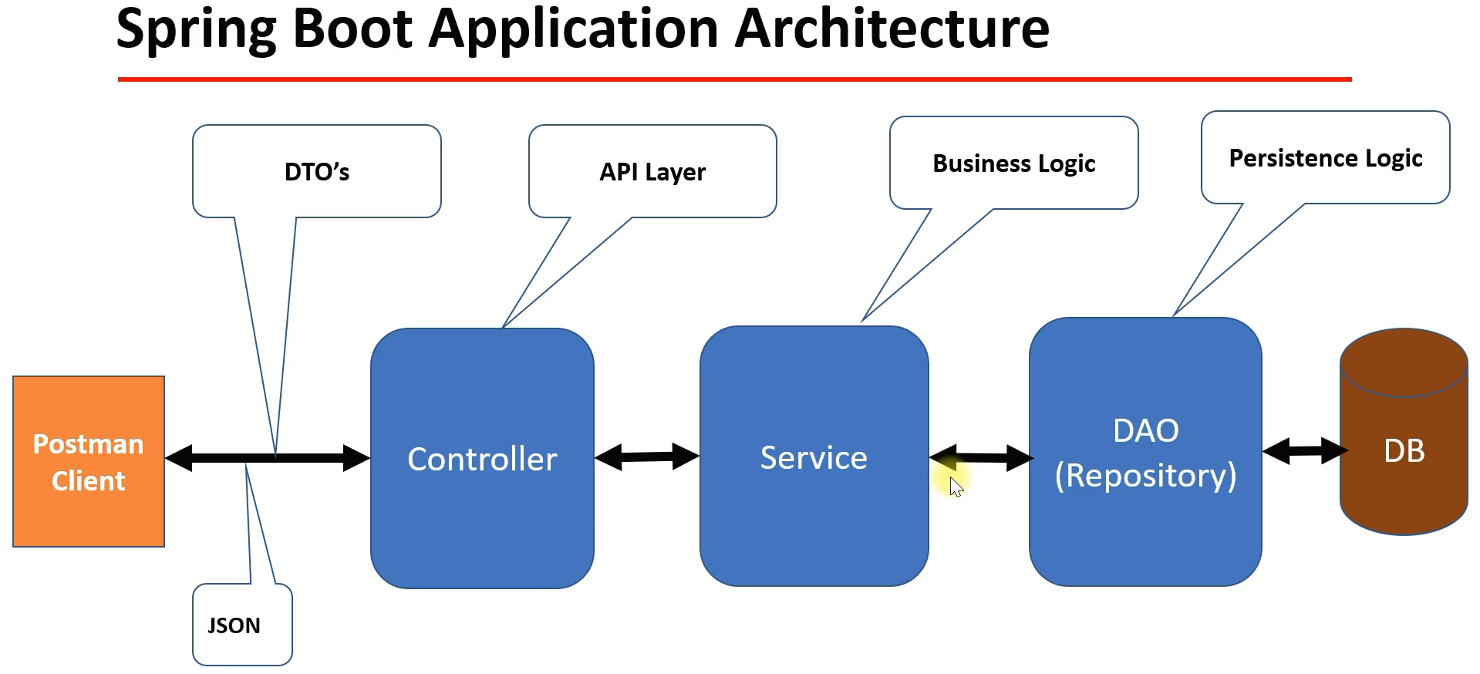
   1. We will use 3-Layer (3-Tier) Architecture.
   2. **Controller Layer**:
      1. It is also called API Layer as it contains all the REST API End Points.
   3. **Service Layer**: Contains Business Logic.
   4. **DAO Layer**:
      1. Also called Repository Layer.
      2. Contains DB related or persistence Logic.
   5. Postman Client:
      1. To call/test REST APIs
   6. DTO:
      1. To transfer data b/w client and server.
   7. JSON:
      1. We will JSON as media type.